EduTutor AI - Project Summary

Core Concept
Intelligent web-based learning platform combining AI-powered assessments with comprehensive analytics for personalized education.
Key Innovations
Technical Innovations
- AI-Powered Quiz Engine: Dynamic question generation based on topic & difficulty
- Real-time Analytics: Instant performance tracking and visualization
- Dual-Role Architecture: Separate interfaces for Students & Educators
- Google Classroom Integration: Seamless LMS synchronization
- Glass-morphism UI: Modern, engaging user interface

Educational Innovations
- Adaptive Learning: Personalized difficulty scaling
- Comprehensive Subject Coverage: Math, Science, History, English + specialized topics
- Progress Visualization: Interactive dashboards and progress tracking
- Educator Empowerment Tools: Classroom analytics and intervention systems

Key Features

For Students
- Personalized quizzes (3-15 questions per session)
- Multiple difficulty levels (Easy, Medium, Hard)
- Real-time performance feedback
- Progress tracking and history
- Topic-specific learning paths

For Educators
- Classroom performance analytics
- Student progress monitoring
- Automated assessment generation
- Encouragement message system
- Leaderboard and benchmarking

Technical Stack
- Backend: Python Flask framework
- Frontend: HTML5, CSS3, JavaScript
- Storage: JSON-based data persistence
- Design: Glass-morphism UI with animated elements
- Integration: Google Classroom API

User Experience
- Responsive Design: Works on all devices
- Engaging Interface: Animated backgrounds and interactive elements
- Intuitive Navigation: Role-based dashboard access
- Visual Feedback: Progress bars and achievement indicators
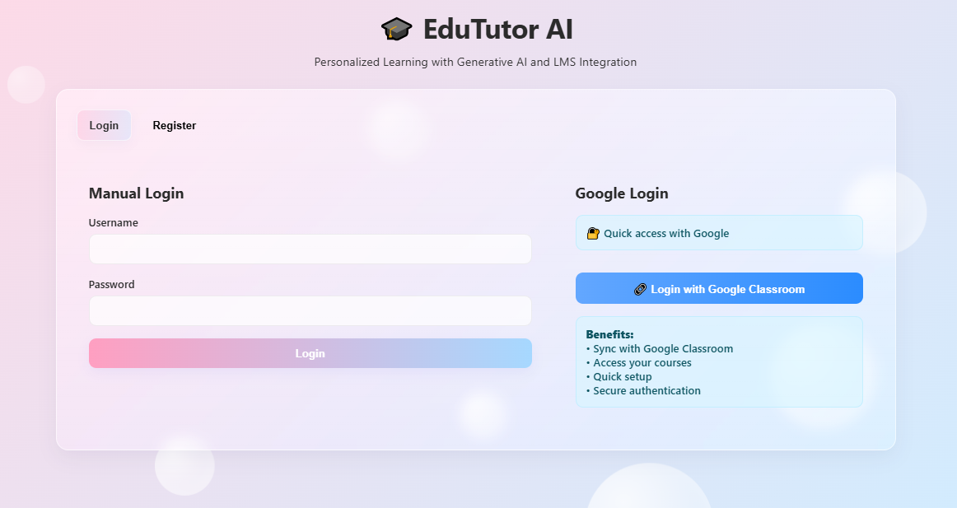

Impact & Benefits

Educational Impact
- Personalized learning experiences
- Data-driven performance insights
- Increased student engagement
- Reduced educator workload

Technical Advantages
- Scalable architecture
- Real-time analytics
- Easy integration with existing systems
- Low maintenance requirements

Future Potential
- Mobile app development
- Advanced AI/ML integration
- Multi-language support
- Expanded subject coverage
- Collaborative learning features
Unique Value Proposition
"EduTutor AI transforms traditional learning into engaging, personalized educational journeys through intelligent technology and data-driven insights."
Key Differentiators:
- Dual-platform serving both students and educators
- Adaptive learning with personalized content
- Seamless integration with existing educational tools
- Comprehensive analytics for informed decision-making
- Modern, engaging interface that promotes learning retention
Target Impact: Improved educational outcomes through personalized, technology-enhanced learning experiences.

